ISTANBUL TECHNICAL UNIVERSITY
TEXTILE ENGINEERING AND DESIGN FACULTY

DIŞ KAPAKTIR.
Taslak ve düzeltilmiş ciltte bulunur.

TEXTILE ENGINEERING DEPARTMENT

PROPOSAL PROJECT TITLE
USE SECOND ROW IF REQUIRED
USE THIRD ROW IF REQUIRED (MAXIMUM OF 3 ROWS)

SENIOR DESIGN PROJECT PROPOSAL

İsmin ilk harfi büyük, diğer harfler küçük yazılacak. Soyad büyük harf yazılacak

Prepared by

111111111 Student Name SURNAME
222222222 Student Name SURNAME
333333333 Student Name SURNAME
444444444 Student Name SURNAME

Supervisor: Prof. Dr. Name SURNAME

MONTH AND YEAR OF PROJECT PROPOSAL EXAM

Öğrenci numarası ad ve soyadı dış kapak formatında yazılacaktır.

Prepared by

111111111 Student Name SURNAME
222222222 Student Name SURNAME
333333333 Student Name SURNAME
444444444 Student Name SURNAME

Sayfa numarası iç kapaktan itibaren saymaya başlar (Ama iç kapakta ve onun arkasında sayfa numarası gösterilmez). Bu sayfa “iii.” sayfaya denk gelmektedir.

Bölüm kesmesi (section break) ekleyip Önsöz sayfası’nı tek numaralı sayfaya denk gelmesi için ayarladık. Bu nedenle iii. sayfadan v. sayfaya atladı. Çıktı alırken iv. sayfayı boş çıkaracak.

Bu bir nottur, çıktı almadan önce siliniz.

PREFACE
Soru: Öncesinde 72 punto – sonrasında 18 punto boşluk nasıl bırakılır?
Cevap: Başlık üzerinde sağa tıklanır, paragraf sekmesinde bu ayarlar bulunmaktadır.
Lorem ipsum dolor sit amet, consetetur sadipscing elitr, sed diam nonumy eirmod tempor invidunt ut labore et dolore magna aliquyam erat, sed diam voluptua. At vero eos et accusam et justo duo dolores et ea rebum. Stet clita kasd gub rgren, no sea takimata sanctus est Lorem ipsum dolor sit amet, consetetur sadipscing elitr, sed diam nonumy eirmod tempor invidunt ut lab ore sit et dolore magna.
ÖNSÖZ
hazırlanırken 1 satır boşluk bırakılır.

Tarih ve yazar isminin aynı hizada olması önerilir.

Month Year | Name Lastname

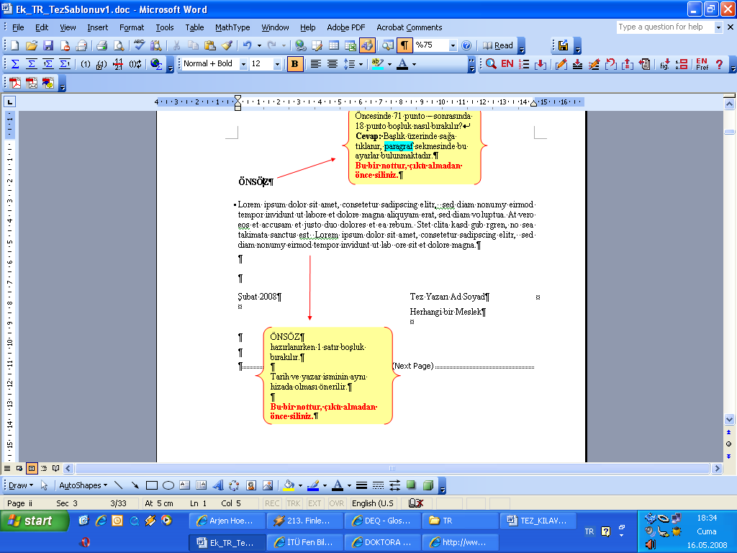
Soru: Çıktıda başlığın yukarıdan 5 cm aşağıda basılacağını nasıl anlarız?
Cevap: Sekme(fare işareti) başlık üzerinde iken ekranın altında bu değer görüntülenir.

Bir sonraki “İçindekiler” bölümünü tek numaralı sayfaya denk gelmesi için çift numaralı olan bu sayfayı boş bıraktık.

Bu bir nottur, çıktı almadan önce siliniz.

TABLE OF CONTENTS
Sayfa yazısı sağa dayalı olur.
Sayfa bilgisi içeren ana başlıkların (içindekiler, çizelge listesi, şekil listesi) altında 6 punto önce, 12 punto sonrası boşlukla yerleştirilmesi önerilir.
İÇİNDEKİLER
hazırlanırken 1 satır boşluk bırakılır.

Sayfa
PREFACE (or ABSTRACT) v
CONTENT vii
ABBREVIATIONS ix
TABLE LIST xi
FIGURE LIST xiii
ÖZET xv
( Tez amacını özetleyen ve ne şekilde tamamlandığını belirten bir iki paragraftan ibaret olmalıdır. Giriş kısmı ile karıştırılmamalı ve proje alt yapısı anlatılmamalıdır. Bu bölümü inceleyen okuyucunun tez içeriğinin kendisini ilgilendirip ilgilendirmediğine karar verebilmelidir. Tercihen tez içeriğinin tam olarak verilebilmesi amacı ile en son yazılan bölüm olması tavsiye edilir.)
SUMMARY xvii
(The thesis should consist of one or two paragraphs summarizing its purpose and stating how it was completed. It should not be confused with the introduction and the project infrastructure should not be explained. The reader who examines this section should be able to decide whether the content of the thesis concerns him or not. Preferably, it is recommended to be the last section to be written in order to give the thesis content in full. It would be appropriate to have the ÖZET section in the form of an English expression instead of word by word translation)
1. INTRODUCTION 1
(Within the scope of the submitted project proposal, the thesis background, purpose and approach to be applied should be defined. In addition to discussing similar designs, the difference of the design carried out in the study should be emphasized.)
1.1 Content of the Design Project (including the client’s need & the statement of the problem) 1
1.2 Objectives of the Design Project 1
1.3 Literature Survey (add if there are standards, codes, technical documents) 2
1.4 Constraints of the Design Problem ( boundaries, limitations) 2
1.5 Application Fields of the Design 3
1.6 GANTT Chart and Team Members Responsibilities 3
2. SELECTION OF APPROPRIATE DESIGN 5
((Please see the explanation given in Section 2. for further understanding. This is the section where different concepts in competition and alternative design solution options to be developed are discussed. The design method and how to overcome the problems encountered during the design phase should be discussed. At least three solutions and selection criteria should be specified.)

2.1 Evaluation Criteria for Design Selection ……………………………..………5
2.2. Conceptual Designs…………………...……………………............................5
2.3. Evaluation of Conceptual Designs ………………..…….................................5
2.4 Description and Properties of Selected Design 5

3. DISCUSSION 9
(This is the section where the selected design proposal is outlined and discussed in detail.)

REFERENCES 27
APPENDICES 30
APPENDIXA1. Technical Drawing Drawings, computer program, garment technical drawings, etc.

ABBREVIATIONS

AIC : Akaike Information Criteria
ANN : Artificial Neural Network
App : Appendix
BP : Backpropagation
CGI : Common Gateway Interface
ESS : Error sum-of-squares
GARCH : Generalized Autoregressive Conditional Heteroskedasticity
GIS : Geographic Information Systems
HCA : Hierarchical Cluster Analysis
Mbps : Megabits per second
St : Station
SWAT : Soil and Water Assessment Tool
UMN : University of Minnesota
Kenar boşlukları “Karşılıklı Kenar Boşlukları” olarak ayarlanır. Alt, üst ve dış kenar boşlukları 2,5 cm olarak, iç kenar boşluğu ise 4 cm olarak ayarlanır.

Değişiklikler tüm belgeye uygulanır.

KISALTMALAR
hazırlanırken 1 satır boşluk bırakılır.
Kısaltma koyu, açıklama normal yazılır.

LIST OF TABLES
Page
Table 1.1 : Tek satırlı ve kolonlar ortalanmış çizelge. 2
Table 2.1 : Çizelge ismi örneği, sonda bitişi belirten nokta olması önerilir. 7
Table 3.1 : Yatay sayfada birden fazla satırlı çizelge isimlendirme: önemli nokta satırların aynı hizadan başlamasıdır. 16
ÇİZELGE LİSTESİ
hazırlanırken 1 satır boşluk bırakılır.

Bir satırı aşan isimlerde satırların burada olduğu gibi aynı hizadan başlamasına özen gösteriniz.

Table 4.1 : Çizelge örneği. 20
Table 5.1 : Beşinci bölümde bir örnek çizelge. 23
Table 6.1 : Altıncı bölümde bir çizelge. 25
Table A.1 : Ekler bölümünde çizelge örneği. 32

LİST of FIGURES
Page
Figure 1.1 : Model yapıları. 2
Figure 2.1 : Üst yapılar. 6
Figure 3.1 : Sinir hücresi, Çetin (2003) ten uyarlanmıştır. 10
Figure 3.2 : Birden fazla satırlı şekil isimlendirmesinde önemli nokta satırların aynı hizadan başlamasıdır. 11
Şekiller ortalanır veya sola yaslanır. Kırmızı çizgi ile gösterildiği gibi iki satırın yazıları hizalanır.

Figure 3.3 : Örnek şekil ismi, sonda bitişi belirten nokta olması önerilir. 12
Figure 3.4 : Yatay tam sayfa şekil. 14
Figure A.1 : Bölgesel haritalar: (a)Yağış. (b)Akım. (c)Evapotranspirasyon … 30

TÜRKÇE TEZ BAŞLIĞI BURAYA YAZILIR
ÖZET
Son yıllarda… Lorem ipsum dolor sit amet, consetetur sadipscing elitr, sed diam nonumy eirmod tempor invidunt ut labore et dolore magna aliquyam erat, sed diam voluptua. At vero eos et accusam et justo duo dolores et ea rebum.
Lorem ipsum dolor sit amet, consetetur sadipscing elitr, sed diam nonumy eirmod tempor invidunt ut labore et dolore magna aliquyam erat, sed diam voluptua.
ÖZET
hazırlanırken 1 satır boşluk bırakılır.

Bu genişletilmiş özet 200 kelime ile 5 sayfa arasında olur.

Türkçe tezlerde Türkçe özetin önce olması önerilir.

Bir sonraki “Summary” bölümü tek numaralı sayfaya denk gelmesi gerekmektedir. Bu sayfa çift numaralı olduğu için boş bırakıldı.. Eğer tek numaralı olsaydı “Summary” bölümü direk bu sayfadan başlardı.

Bu bir nottur, çıktı almadan önce siliniz.

THESIS TITLE IN ENGLISH IS WRITTEN HERE
SUMMARY
Lorem ipsum dolor sit amet, consetetur sadipscing elitr, sed diam nonumy eirmod tempor invidunt ut labore et dolore magna aliquyam erat, sed diam voluptua.
Stet clita kasd gub rgren, no sea takimata sanctus est Lorem ipsum dolor sit amet, consetetur sadipscing elitr, sed diam nonumy eirmod tempor invidunt ut lab ore sit et dolore magna.
SUMMARY
hazırlanırken 1 satır boşluk bırakılır.
This is an extended summary which is min 200 words to max 5 pages

Bu bir nottur, çıktı almadan önce siliniz.

Giriş bölümü tek numaralı sayfadan başlaması gerekmektedir. Bir sonraki sayfa çift numaralı olacağı için 1 tane boş sayfa ekledik.

Bu bir nottur, çıktı almadan önce siliniz.

- INTRODUCTION
Lorem ipsum dolor sit amet, consetetur sadipscing elitr, sed diam nonumy eirmod tempor invidunt ut labore et dolore magna aliquyam erat, sed diam voluptua.
Lorem ipsum dolor sit amet, consetetur sadipscing elitr, sed diam nonumy eirmod tempor invidunt ut labore et dolore magna aliquyam erat, sed diam voluptua.
  - Content of the Design Project
Lorem ipsum dolor sit amet, consetetur sadipscing elitr, sed diam nonumy eirmod tempor invidunt ut labore et dolore magna aliquyam erat, sed diam voluptua.
  - Objectives of the Design Project
Lorem ipsum dolor sit amet, consetetur sadipscing elitr, sed diam nonumy eirmod tempor invidunt ut labore et dolore magna aliquyam erat, sed diam voluptua.
EXAMPLE FIGURE
Figure 1.1: Model yapıları.
  - Literature Survey
Lorem ipsum dolor sit amet, consetetur sadipscing elitr, sed diam nonumy eirmod tempor invidunt ut labore et dolore magna aliquyam erat, sed diam voluptua. At vero eos et accusam et justo duo dolores et ea rebum.
Table 1.1: Tek satırlı ve kolonlar ortalanmış çizelge.
Kolon A | Kolon B | Kolon C | Kolon D
Satır A | Satır A | Satır A | Satır A
Satır B | Satır B | Satır B | Satır B
Satır C | Satır C | Satır C | Satır C
  - Constraints of the Design Problem
  - Application Fiield of the Design
  - GANNT Chart and Team Members Responsibilities

- SELECTION of APPROPRIATE DESIGN
Project Title : Desing of Textile Based Sensors for Exeskeletons
Evaluation Criteria for Design Selection | In this section, design criteria will be discussed throughoutly. In this example, criteria for Textile Based Sensors for Exeskeletons will be introduced such as linearity of sensors, ease of manufacturing, etc. In your thesis, you sould identify your criteria for design selection and discuss them in detail.
Conceptual Designs | In this section, please discuss your alternative design options in detail. In the example , capacitive, inductive and resistive sensor technologies will be discussed as conceptional designs. Please describe this approach for your conceptual designs as well during the preperation of your thesis.
Evaluation of Conceptual Designs | This part gives detailed comparison which includes advantages and disadvantages of each conceptual design.
Description and Properties of Selected Design | Based on the evaluation of conceptual design, select the most appropriate design and discuss it throughoutly.
2.1. Evaluation Criteria for Design Selection
2.2. Conceptual Designs
2.3 Evaluation of Conceptual Designs
2.4. Description and Properties of Selected Design
3. DISCUSSIONS
Lorem ipsum dolor sit amet, consetetur sadipscing elitr, sed diam nonumy eirmod tempor invidunt ut labore et dolore magna aliquyam erat, sed diam voluptua.
At vero eos et accusam et justo duo dolores et ea rebum. Stet clita kasd gub rgren, no sea takimata sanctus est Lorem ipsum dolor sit amet, consetetur sadipscing elitr, sed diam nonumy eirmod tempor invidunt ut lab ore sit et dolore magna (3.1).
Formüller sağa yaslanır, koyu yazılır.
Oluştururken yardımcı kaynak:
http://support.microsoft.com/kb/313017
Bu bir nottur, çıktı alamadan önce siliniz.
(3.1)
Parametreler tek tek açıklanır.

Şekiller ortalanır veya sola yaslanır. Kırmızı çizgi ile gösterildiği gibi iki satırın yazıları hizalanır.

Bu bir nottur, çıktı alamadan önce siliniz.

ÖRNEK
ŞEKİL
Figure 3.1: Birden fazla satırlı şekil isimlendirmesinde önemli nokta
satırların aynı hizadan başlamasıdır.

ÖRNEK ŞEKİL
Figure 3.2: Yatay tam sayfa şekil
Sayfa numarası, kağıt dikey tutulduğunda sayfanın kısa kenarının alt-ortasına, yatay tutulduğunda uzun kenarınının alt-ortasına yazılır. Bkz kılavuz 2.2.4

Bu bir nottur, çıktı alamadan önce siliniz.
Stet clita kasd gub rgren, no sea takimata sanctus est Lorem ipsum dolor sit amet, consetetur sadipscing elitr, sed diam nonumy eirmod tempor invidunt ut lab invidunt ut labore et ore sit et dolore kasd gub rgren, no sea takimata magna (Nelson, 1988).
Cümle sonunda referans

Cümle başında referans

Numaralı referans.

Bu bir nottur, çıktı almadan önce siliniz.
Lorem ipsum dolor sit amet, consetetur sadipscing elitr, sed diam nonumy eirmod tempor invidunt ut labore et dolore magna aliquyam erat, sed diam voluptua. At vero eos et accusam et justo duo dolores et ea rebum. At vero eos et accusam et justo duo dolores et ea rebum. Lorem ipsum dolor sit amet, consetetur sadipscing elitr, sed diam nonumy eirmod tempor invidunt ut labore et dolore magna aliquyam erat, sed diam voluptua. At vero eos et accusam et justo duo dolores et ea rebum [1].
Nelson (1988) analized lorem ipsum dolor sit amet, consetetur sadipscing elitr, sed diam nonumy eirmod tempor invidunt ut labore et dolore magna aliquyam erat, sed diam voluptua. At vero eos et accusam et justo duo dolores et ea rebum.

Table 3.1: Prof.Dr. Galip G. TEPEHAN Yatay sayfada birden fazla satırlı çizelge isimlendirme:
önemli nokta satırların aynı hizadan başlamasıdır.
Çizelge ortalanır veya sola dayalıdır. Kırmızı çizgi ile gösterildiği gibi iki satırın yazıları hizalanır
Bu bir nottur, çıktı almadan önce siliniz.
Parametre | Kolon 2 | Kolon 3 | Kolon 4 |  |  | Kolon 5
 |  |  | Alt kolon | Alt kolon | Alt kolon | Alt kolon | Alt kolon
Satır 1 | -7.680442 | 7.6986348 | 0.00 | 0.00 | 0.00 | 12 | 12
Satır 2 | 140 | - | 0.50 | 0.00 | 0.00 | 0 | 0
Satır 3 | 37.174357 | 37.16192697 | 0.00 | 0.00 | 0.00 | 0 | 24
Satır 4 | 140 | - | 0.50 | 0.00 | 0.00 | 0 | 0
Satır 5 | 37.174357 | 37.16192697 | 0.00 | 0.00 | 0.00 | 0 | 24
Satır 6 | 140 | - | 0.50 | 0.00 | 0.00 | 0 | 0
Satır 7 | 37.174357 | 37.16192697 | 0.00 | 0.00 | 0.00 | 0 | 24
Satır 8 | 140 | - | 0.50 | 0.00 | 0.00 | 0 | 0
Satır 9 | 37.174357 | 37.16192697 | 0.00 | 0.00 | 0.00 | 0 | 24
Satır 10 | 140 | - | 0.50 | 0.00 | 0.00 | 0 | 0
Satır 11 | 37.174357 | 37.16192697 | 0.00 | 0.00 | 0.00 | 0 | 24
Satır 12 | 140 | - | 0.50 | 0.00 | 0.00 | 0 | 0
Satır 13 | 37.174357 | 37.16192697 | 0.00 | 0.00 | 0.00 | 0 | 24
Satır 14 | 140 | - | 0.50 | 0.00 | 0.00 | 0 | 0
Satır 15 | 37.174357 | 37.16192697 | 0.00 | 0.00 | 0.00 | 0 | 24

Arkalı önlü baskılarda her bölümün ilk sayfasının (birinci derece başlıkların) okuma yönünde sağdaki sayfada olmasına dikkat edilir.
Bu bir nottur, çıktı alamadan önce siliniz.

Arkalı önlü baskılarda her bölümün ilk sayfasının (birinci derece başlıkların) okuma yönünde sağdaki sayfada olmasına dikkat edilir.
Bu bir nottur, çıktı almadan önce siliniz.

KAYNAKLAR yazar soyadına göre, A dan Z ye sıralanır.
Bu bölümde 1 satır boşluk bırakılır.
Bu bir nottur, çıktı almadan önce siliniz.

REFERENCES
Abrahart, R. J., and See, L., 1998: Neural Network vs. ARMA Modelling: Constructing Benchmark Case Studies of River Flow Prediction. In GeoComputation ’98. Proceedings of the Third International Conference on GeoComputation, University of Bristol, United Kingdom, 17–19 September (CD-ROM).
Abrahart, R. J., and See, L., 2000: Comparing neural network and autoregressive moving average techniques for the provision of continuous river flow forecasts in two contrasting catchments, Hydrolog. Process., 14, 2157–2172.
Acar, M. H. and Yılmaz, P., 1997. Effect of tetramethylthiuramdisulfide on the cationic poymerization of cylohexeneoxide, The 2nd International Conferences on Advanced Polymers via Macromolecular Engineering, Orlando, Florida, USA, April 19-23.
Box, G. E. P., and Jenkins, J. M., 1976: Time Series Analysis: Forecasting and Control. Holden-Day, San Francisco, CA.
Burke, W.F. and Uğurtaş, G., 1974. Seismic interpretation of Thrace basin, TPAO internal report, Ankara, Turkey.
Burlando, P., Rosso, R., Cadavid, L. G., and Salas, J. D., 1993: Forecasting of Short-term Rainfall Using ARMA Models. Journal of Hydrology. Vol. 144, no. 1-4, pp. 193-211.
IOC-UNESCO, 1981. International bathymetric chart of the Mediterranean, Scale 1:1,000,000, 10 sheets, Ministry of Defence, Leningrad.
LePichon, X., 1997. Kişisel görüşme.
McCaffrey, R. and Abers, G., 1988. SYN3: A program for inversion of teleseismic body wave forms on microcomputers, Air Force Geophysics Laboratory Technical Report, AFGL-TR-88-0099, Hanscomb Air Force Base, MA.
Nelson, M.R., 1988. Constraints on the seismic velocity structure of the crust and upper mantle beneath the eastern Tien Shan, Central Asia, PhD Thesis, MIT, Cambridge, MA.
Roberts. S. and Jackson, J.A., 1991. Active normal faulting in central Greece: An overview, in The Geometry of Normal Faults, Spec. Publ. Geol. Soc. Lond., 56, p. 125-142, Eds. Roberts, A.M., Yielding, G. and Freeman, B., Blackwell Scientific Publications,Oxford.
Sisaky, A., Golab, F. and Myer, B., 1989. Rust resistant potatoes, United Kingdom Patent, No: 2394783 dated 23.1.1989.
TS-40561, 1985. Çelik yapıların plastik teoriye göre hesap kuralları, Türk Standartları Enstitüsü, Ankara.
Kullanılan Standartlar verilmelidir
Kişisel görüşme neticesi bilgi aktarımı, tavsiye ve görüş alınmışsa belirtilmelidir.
Internet kaynaklarında yazar belirsiz ise (anonim), tam link ve alındığı tarih verilmelidir..
Bu bir nottur, çıktı almadan önce siliniz.

Url-1 <http://www.mohid.com>, alındığı tarih 29.06.2006.
Url-2 <http://www.elet.polimi.it/ >, alındığı tarih 10.01.2007.
Usta, V… 2010. Kişisel Görüşme.
Vanden, G., Knapp, S., & Doe, J. (2001). Role of referenceelements in the selection of resources by psychology undergraduates. Journal of Bibliographic Research, 5, 117-123. Retrieved October 13, 2001, from http://jbr.org/articles.html
[1] Abrahart, R. J., and See, L., 1998: Neural Network vs. ARMA Modelling: Constructing Benchmark Case Studies of River Flow Prediction. In GeoComputation ’98. Proceedings of the Third International Conference on GeoComputation, University of Bristol, United Kingdom, 17–19 September (CD-ROM).
[2] IOC-UNESCO, 1981. International bathymetric chart of the Mediterranean, Scale 1:1,000,000, 10 sheets, Ministry of Defence, Leningrad.
KAYNAKLAR
Numaralı gösterim, metin içindeki kullanıldığı sıra esas alınır.
Bu bölümde 1 satır boşluk bırakılır.
Bu bir nottur, çıktı almadan önce siliniz.

APPENDICES
APPENDIX A.1 : Teknik Resimler

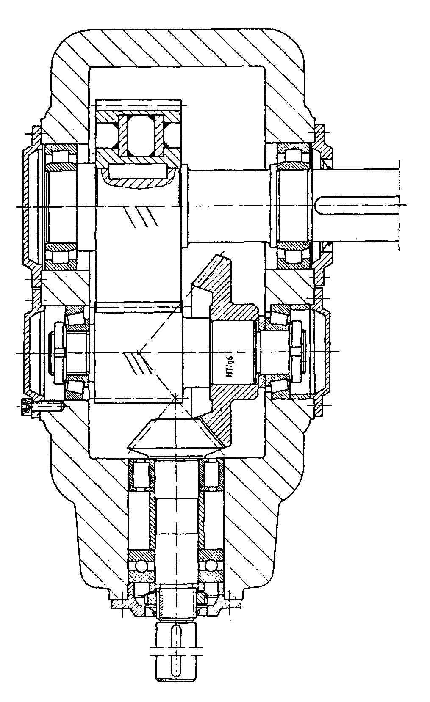
Table A.1: Çizimler …
Çoklu şekillerde herbir farklı şekil, gerekiyorsa (metin içinde herbirine birine atıf yapılacaksa) teker teker harflendirilerek ve açıklamasıyla verilir. Genel bir isim yeterli ise harflendirmeye eklerde gerek duyulmaz.
Bu bir nottur, çıktı alamadan önce siliniz.
Figure A.1: Ekler bölümünde çizelge örneği.
Kolon A | Kolon B | Kolon C | Kolon D
Satır A | Satır A | Satır A | Satır A
Satır B | Satır B | Satır B | Satır B
Satır C | Satır C | Satır C | Satır C

Curriculum Vitae | VESİKALIK  FOTO
Name SURNAME:
Place of Birth and Date of Birth:
Address:
List of Publications:
- Ganapuram S., Hamidov A., Demirel, M. C., Bozkurt E., Kındap U., and Newton A., 2007: Erasmus Mundus Scholar's Perspective On Water And Coastal Management Education In Europe. International Congress - River Basin Management, March 22-24, 2007 Antalya, Turkey.
ÖZGEÇMİŞ hazırlanırken 1 satır boşluk bırakılır. Fotoğraflı ve yayın listeli (yayını varsa) özgeçmiş önerilir. Fotoğraf ve adres şart değildir.
Bu bir nottur, çıktı alamadan önce siliniz.

