INSURANCE PROCEDURE PRIOR TO INTERNSHIP

My Internships > Detail
If the recorded information is certain, it will be approved.
Internship Registration
To be filled in and recorded according to the agreement with the company.
www.portal.itu.edu.tr

Enter by username and password

Internship Liability Document
To be filled in after getting its hard-copy if the company requests.
THE COMPANY
Internship dates will be determined.

*Recorded information can be edited later.

*At least 15 days earlier.
*No change is possible after approval. When imperative, a help ticket addressed to İTU Merkez Staj Birimi (ITU Central Internship Unit) needs to be created.

Internship Contract and Document Ek 1
Created after the approval procedure.
Internsip Contract and Document Ek 1 will be stamped and signed in the following order:
- By the student
- By the company
- By Internship Comittee (Assoc. Prof. Dr. Sena C. Duru)
-Dekanlık (Doç. Dr. Nazan Okur)

The signed Internship Contract and form of Document Ek 1 will be uploaded to the upload module.

* At least 6 days before starting the intenship.

NOTE: In order to be able to register for internship, students who have not done internship before must complete Health and Safetey training by applying from www.portal.itu.edu.tr. STUDENTS WHO HAVE NOT TAKEN AND PASSED THE HEALTH AND SAFETY TRAINING ARE NOT ENTITLED FOR INTERNSHIP REGISTRATION.

PLEASE READ THE FOLLOWING EXPLANATIONS CAREFULLY
1-) Enter from www.portal.itu.edu.tr with username and password.
2-) Intern student downloads the “Internship Liability Document” from the Documents, fills it in and submits it to the company if the company requests that document, which tells that the internship is compulsory and that internship insurance is provided by the faculty.
3-) The company specifies the dates for the compulsory internship for the student. If the company works on Saturdays as well, this must be taken into account in determining the internship period and a letter stating that the company works on Saturdays must be received ftom the company.
4-) The following link is clicked and filled in “Staj Kayıt”.
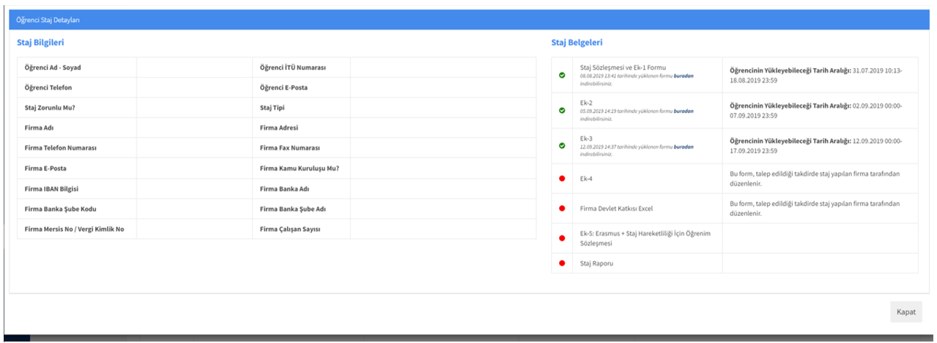
- In the field of “Staj Türü” (Type of Internship), only one of the following four types is written: Yarn (iplik), Weaving/knitting (Dokuma/örme), apparel/planning (konfeksiyon/planlama) or dying-finishing-laboratory (boya-terbiye-laboratuvar). In entering internship information into the Internship Registration System (Staj Kayıt Sistemi), students must do the entering separately for each type of internship even if the company is the same for more than one type of intership.
- Full name of the company and the name of the city/town must be written in the field of Company Name (Firma adı), for example, ETF Tekstil Konfeksiyon İhr. Turizm San. Tic. A.Ş. İstanbul.
- The number of days between the internship start date and internship end date must not exceed the number of days of compulsary internship. For the number of days of compulsary internship, please refer to .....
- You are expected to enter company information, the internship start date and internship end date correctly and completely since the information you enter will be used for SGK insurance and also for evaluating your internship. You are allowed to edit or change the information you enter before confirmation.
5-) After entering all the information, click “save”.
Note: Saving only records the information into the memory under “Staj Bilgileri”. It is not the ultimate operation, change is still possible.
6-) After clicking “Stajlarım > Detay”, confirmation menu will be reached. Changing information is possible until fifteen days before the start day. The information entered is approved by clicking confirmation button.
Note: No change on internship information is allowed after confirmation. In the case of extraordinary circumstances, a help ticket to İTU Merkez Staj Birimi (Central Internship Office) is to be issued.
Note: Confirmation is allowed until fifteen days before the internship start date. So please do the internship confirmation AT THE VERY LATEST 15 days before starting the internship. Otherwise you cannot start internship on the required date.
7-) Documents of Ek 1, Ek 2 and Ek 3 appear after confirming the internship.
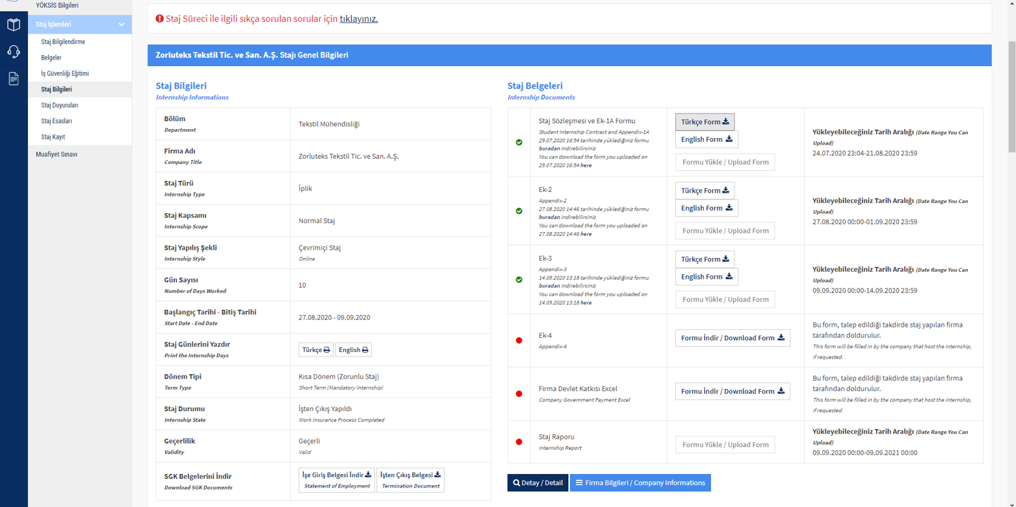
- Ek 1 form is “Staj Kabul Yazısı” (Internship Acceptance), Ek 2 form is “Staj Başlama Belgesi” (Internship Start Document) and Ek 3 form is “Staj Bitiş Belgesi” (Internship End Document).
- Students who have entered and confirmed the internship information upload Document Ek 1 that they have had the company approved to the system 6 days before the internship start date AT THE VERY LATEST.
- Internship Start Form (Ek 2) is filled in, approved by the company and uploaded by the student to Internship Module (Staj Modülü) in Portal within the FIRST 5 DAYS of internship start. Otherwise, your internship is automatically cancelled by the system!
- Internship End Form (Ek 3) is filled by the company and uploaded to the system from Portal within the FIRST 5 DAYS after the internship ended. Otherwise, your internship is automatically cancelled by the system!
8-) When you submit your Internship Report, in order for the results of the accepted internships to be entered into the system, your record needs to have been already created in the system. This is a technical requirement. Consequently, it is absolutely not possible to do any internship entering of students who have not already entered internship record.
9-) You can follow your internship status from “Staj Bilgilerim” after entering and confirming your internship record and uploading the internship documents to ITU Portal. Status information of “İşe giriş İşlemi Tamamlandı” means that insurance procedure of the student is completed. The procedure that you need to do prior to internship is completed. In case the company requests, you can download from ITU Portal the document of “Sigorta İşe Giriş Belgesi”, which shows that you are insured.
10-) Upon completion of the internship, the followings will be uploaded to the system: The Internship Report, Student Contract, Internship Application Form (Ek 1), Internship work Calender, Internship Start Form (Ek 2), Internship End Form (Ek 3), Company Evaluation Form, Student Evaluation Form and the document proving that the company works on Saturdays, if internship is done atweekends as well. Students must collect all of these document.
**** STUDENTS ARE OBLIGED TO UPLOAD THEIR INTERNSHIP REPORT ALONG WITH ALL THE NECESSARY ADDITIONAL DOCUMENTS TO NINOVA PLATFORM

